**SketchRetopo User Guide**

written by Kenshi Takayama

<kenshi84@gmail.com>

February 2014

This is a user guide for SketchRetopo, a prototype system accompanying the following publication:

Kenshi Takayama, Daniele Panozzo, Alexander Sorkine-Hornung, Olga Sorkine-Hornung

Sketch-Based Generation and Editing of Quad Meshes

ACM Transactions on Graphics vol.3 no.4 (SIGGRAPH 2013)

http://doi.acm.org/10.1145/2461912.2461955

***Part I – Basics***

**Install Zenity**

SketchRetopo uses Zenity (<https://live.gnome.org/Zenity>) to show various kinds of dialog boxes (e.g., file chooser). An installer for Windows (zenity-2.28.0_win32-3.exe) is included in the package (which can also be downloaded from <http://www.placella.com/software/zenity/>). For Windows users, make sure that the system knows the path to zenity.exe by typing “zenity” on the Command Prompt. If not, add the path to the PATH system environment variable.

**Importing Base Mesh**

|  |  |
| --- | --- |
| After launching the system by double-clicking the executable, the screen will look like this:  First, you need to import a mesh file to be retopologized. Click file 🡺 import base mesh .  A file selection window will open up, where you can select a mesh file (supported format: OBJ, OFF, PLY, STL).  Now you are ready to start retopologizing this 3D model! |  |

**Camera Control**

The camera control is made similar to that in Autodesk Maya™. Press **😐** and drag with the left/right/middle mouse button to rotate/zoom/pan the camera, respectively. For mice without a middle button, the camera can be panned also by pressing **** + **😐** and dragging with the left mouse button.

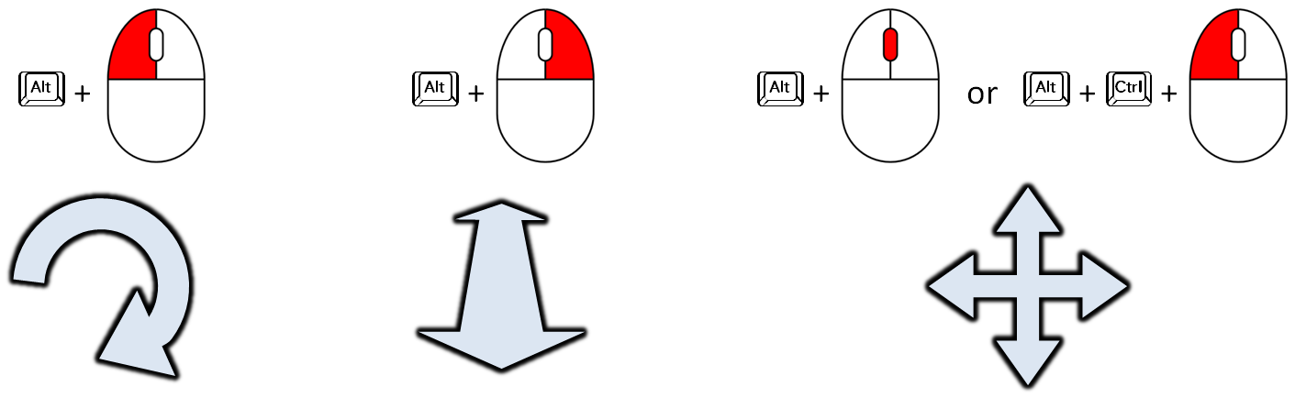

The camera direction can also be snapped to the closest world coordinate axis direction by pressing **** + **😐** when finishing the camera rotation.

**Basic Sketching (shortcut: )**

The system has ten different modes for editing, and the current mode is shown at the bottom left of the screen. The mode is initially set to this “basic sketching” mode.

NOTE Most modeling operations in the system are done with the left mouse button. Therefore we assume it implicitly when referring to clicking and dragging with the left mouse button, and otherwise we explicitly describe which mouse button to use.

|  |  |
| --- | --- |
| You can draw a freeform curve on the model by simply dragging.  An intersection of two curves is marked with a red circle.  If the new curve’s starting point is close to an existing curve’s open endpoint (green dot), they are snapped.  The snapping radius is shown with a subtle transparent sphere around the mouse cursor. It can be adjusted by dragging with the right mouse button with **** pressed.  Once a region is bounded by a loop of curves with four corners, a new patch is generated immediately. You can switch between default rendering mode and quad-only rendering mode by pressing **** (spacebar).  You can draw an “eraser” curve by dragging while pressing ****. Existing curves intersecting with the eraser curve will be deleted. You can also erase all open-ended curves by pressing ****.  A curve’s endpoint can be snapped to the middle of an existing curve, making T-junction (rendered as blue semicircle). Note that the patch disappeared now because an open-ended curve was added inside the patch.  You can extend an existing open-ended curve by drawing a new curve from the endpoint while pressing ****.  You can create N-sided patches where 2 N 6. Patches with different number of sides are rendered with different colors. |  |

**Undo & Redo**

Press **** + **** to undo and **** + **** to redo any of your edit at any time during the modeling. Note, however, that the edit history is cleared when you import a new mesh, load a new XML file, or change the symmetry setting (explained later).

**Topology Editing (shortcut: )**

**-- Changing the number of edge subdivisions --**

|  |  |
| --- | --- |
| You can select a boundary curve of patches (yellow) by simply clicking. The selected curve’s color becomes red.  You can press **** or **** to increase or decrease the number of edge subdivision for the selected curve.  Multiple curves can be selected and deselected by clicking while pressing ****. Clicking anywhere else will clear the current selections.  You can also select a set of curves that lie on the same “quad strip” traced from the clicked edge by clicking while pressing ****. This is only for additive selection.  You can move around irregular vertices (i.e., vertices with more or less than four adjacent quads) of a rectangular patch by pressing the mouse button inside the patch (the exact location doesn’t matter) and dragging.  For patches with four irregular vertices, you can increase the distance between them by dragging while pressing ****.  You can decrease the distance by “pushing” them against the patch boundary with simple dragging.  One thing to note is that topology editing for pentagonal patches is supported only partially; the quadrangulation fails especially when you specify very small number of edge subdivisions at some sides of the patch. The failure of quadrangulation is indicated by dark color with blue points along the boundary.  Another thing to note is that the total number of edge subdivision along a patch boundary must always be even; otherwise the quadrangulation fails. To avoid this issue, the system chooses even number of edge subdivisions by default, and pressing **** and **** changes the number of edge subdivision by two. You can introduce odd number of edge subdivision for any patch boundary by pressing **** or **** to increase or decrease the number of edge subdivision by one. |  |

**Save & Load**

|  |  |
| --- | --- |
| You can save the current modeling data (i.e., the base mesh, sketched curves, final quads, material texture) into an XML file by clicking file 🡺  save xml . You can load the saved data by clicking   file 🡺 load xml .  The current file name is shown at the title bar.  Once you start working with an XML file, the system saves the current data into the file automatically for every 30 seconds if file 🡺 autosave is checked. |  |

**Exporting Retopologized Mesh**

|  |  |
| --- | --- |
| You can export the retopologized mesh by clicking  file 🡺 export retopo mesh (supported format: OBJ, OFF, PLY, STL).  NOTE Maya 2014 seems to have problems reading the exported OBJ file. Please try some other software (e.g., ZBrush, MeshLab) to read the file and export it again. |  |

***Part II – More Tools***

**Deform Curves (shortcut: )**

|  |  |
| --- | --- |
| You can reposition a corner of curves (or a curve’s open endpoint) by dragging.  You can deform the shape of a curve by dragging.  You can also “oversketch” a new curve that starts and ends at the same existing curve by dragging while pressing ****.  You can smooth a curve by dragging while pressing ****. This smoothing operation is accessible from other curve-drawing modes (e.g., basic sketching). |  |

**Move Vertices (shortcut: )**

|  |  |
| --- | --- |
| A big yellow sphere is shown around the mouse cursor, which represents the brush radius. You can adjust the brush radius by dragging with the right mouse button.  You can move vertices of the retopologized mesh by dragging. Vertices inside the brush are moved with smooth falloff weights.  You can smooth the distribution of vertices by dragging while pressing ****.  You can also apply one step of global smoothing by pressing ****. |  |

**Corner Editing (shortcut: )**

|  |  |
| --- | --- |
| T-junctions are formed in several ways (e.g., by drawing a curve from the middle of an existing curve) and they directly influence the resulting mesh topology. You can adjust the configuration of T-junctions and ordinary corners using the corner editing tool.  You can switch the configuration between T-junction and ordinary corner for a vertex on a patch’s boundary by dragging from inside the patch (a pink line appears) and releasing the mouse button at the vertex.  Note that a vertex with T-junction for some patch must be an ordinary corner for at least one other patch (i.e., a vertex cannot be T-junction for all of its adjacent patches). This is due to constraints of our particular implementation.  You can also create a new corner at the middle of a curve, or erase a corner with only two adjacent curves, by clicking while pressing ****. |  |

**Spine Sketching (shortcut: )**

|  |  |
| --- | --- |
| The brush radius is shown with a blue sphere, which can be adjusted by dragging with the right mouse button.  You can create a new patch by simply drawing a single curve. The brush radius determines the width of the new patch.  If the curve’s endpoint is close to an existing curve, the new patch will be snapped to it (*orthogonal snapping*).  If the curve is roughly parallel and close to an existing patch boundary, the new patch will be snapped to it differently (*parallel snapping*).  The parallel snapping can stop at the middle of the stroke, creating T-junctions. |  |

**Autocompletion (shortcut: )**

|  |  |
| --- | --- |
| As you drag along the boundary curves of existing patches, a green square or triangle will appear as a preview of autocompletion. Releasing the mouse button “freezes” the preview.  You can accept the current suggestion by clicking anywhere.  The size of the suggested patch is determined by the brush radius, which can be adjusted by dragging with the right mouse button.  The system suggests the largest possible patch by default. You can browse other alternatives by pressing **** or ****. (If you don’t see any change, try pressing the key a few times.)  When a suggested patch is in a concave area, you can also choose a triangular patch by pressing ****. |  |

**Laser Cutting (shortcut: )**

|  |  |
| --- | --- |
| You can draw a line (shown in purple) which defines a cutting plane. An intersecting curve between the base mesh and the cutting plane is traced from the starting point of the purple line. |  |

**Cylinder Sketching (shortcut: )**

|  |  |
| --- | --- |
| You can draw a curve connecting two loops, typically created with the laser cutting tool. The system generates three other curves connecting the loops.  If one of the loops has some corners, the other loop must have no corners or the same amount of corners, and the sketched curve’s endpoints must be on one of those corners. |  |

**Edge Loop Insertion (shortcut: )**

|  |  |
| --- | --- |
| You can move your mouse cursor along patch boundaries and see the preview of edge loop insertion (in green). You can perform the actual insertion by clicking. |  |

***Part III – Options***

**Symmetry**

|  |  |
| --- | --- |
| You can tell the system that the base mesh is symmetric about X=0 plane by checking config 🡺  symmetric . The X<0 side becomes dark, and you can only work with the X>0 side. |  |

Note that changing the symmetry setting will discard all of the existing curves, which you cannot undo or redo. Therefore we recommend doing this right after importing the base mesh.

**Projection Offset**

|  |  |
| --- | --- |
| The sketched curves and generated quad meshes are placed slightly off the base mesh to circumvent the infamous “Z-fighting” issue.  The amount of offset can be adjusted by config 🡺  proj offset . Note that this is a global parameter and changing it will affect all of the existing curves and quad meshes. |  |

**Default Quad Size and Curve Sampling**

|  |  |
| --- | --- |
| The default number of edge subdivision for a new patch’s boundary is determined based on the “default quad size” parameter which can be adjusted by dragging with the right mouse button while pressing ****.  When you create or edit a curve, it is resampled at a certain interval which can be adjusted by dragging with the right mouse button while pressing **** + ****. When your model has both very large and small parts (e.g., torso and nasal cavity), you should adjust this parameter accordingly so that the curves are resampled appropriately. |  |

**Camera Control Options**

|  |  |
| --- | --- |
| You can restrict the “screen vertical plane” (i.e., a plane defined by the camera up and eye directions) to be aligned with the object space Y axis by checking camera 🡺 upright . You can switch to orthogonal projection by checking camera 🡺  ortho .  When camera 🡺 auto center is checked, the center of camera rotation is updated each time the camera is panned. The camera center is updated to the point visible at the center of the screen. The camera center can be reset to the center of the model’s bounding box by pressing **** (zero).  The camera information along with the window position and size can be displayed on a dialog box by pressing ****. You can save this text somewhere and later paste it into this textbox and press OK to restore the camera and window configuration.  You can switch the “turntable mode” on/off by pressing ****. Its speed can be adjusted by   camera 🡺 turntable speed . |  |

**Rendering Modes**

You can switch to quad-only and basemesh-only rendering modes by pressing **** and **** + ****, respectively. You can hide auxiliary information (i.e., patch boundaries, corners, irregular vertices) for the quad-only mode by unchecking render 🡺 show auxiliary .

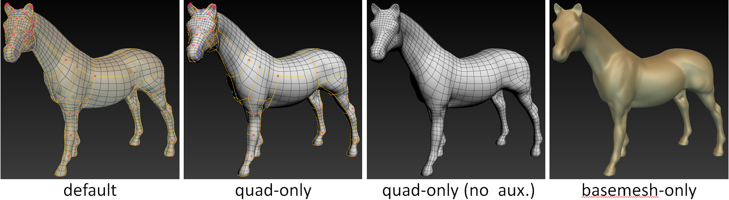

**Material Texture**

You can apply your favorite material texture in PNG format to the model by clicking file 🡺 load material . Note that the material texture is also saved in the XML file.

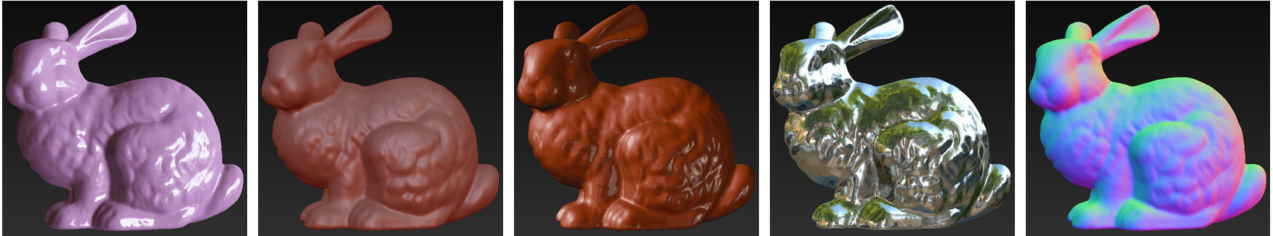

***Acknowledgements***

* 外字神社 (www.gaiji.info): the “KeyboardFontPlus” font